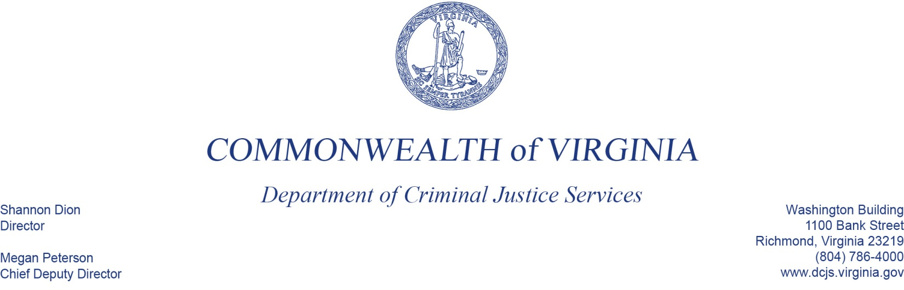
May 21, 2020

Katharine Sullivan
Principal Deputy Assistant Attorney General
U.S. Department of Justice
Office of Justice Programs
Office for Victims of Crime
810 Seventh Street NW
Washington, D.C. 20531

Dear Ms. Sullivan:

DCJS certifies to the following points:

- it complies with and will continue to comply with the requirements of 34 U.S.C. 20103(a)(2) (applicable provisions of VOCA), and 28 C.F.R. Part 94, Subpart B (the VOCA Assistance Program Rule), and will require subrecipient compliance with these requirements, as applicable (e.g., 28 C.F.R. 94.111 to 94.122). See 28 C.F.R.94.103.

- award funds will be used only to provide services to victims of crime, except for a maximum of 5 percent that may be used for administration and training. See 28 C.F.R. 94.107.

- award funds will not be used to supplant state and local public funds that would otherwise be available for crime victim services, or state funds that would otherwise be available for purposes of administering the state victim assistance program. See 28 C.F.R. 94.108.

- it will allocate a minimum of 40 percent of the total grant to the three priority victim categories (sexual assault, domestic violence, and child abuse) and underserved victims of violent crime by subawarding at least 10 percent to each of four categories. Underserved victims of violent crime are designated by the state administering agency by the type of crime or demographic characteristics of the victim, or both. This requirement may be waived by the OVC director upon a showing of good cause by the applicant. See 28 C.F.R. 94.104.7

Ms. Katherine Sullivan
May 21, 2020
Page Two

- it will maintain fund accounting, auditing, and other records, as necessary, to assure fiscal control, proper fund management, and efficient disbursement of funds received under the VOCA Victim Assistance program. See “Financial Management and System of Internal Controls,” above.

- it will maintain documentation describing its methodology for selecting subrecipients. See 28 C.F.R. 94.104(e).

- it will provide OVC with the name of a civil rights contact person who is responsible for ensuring that all applicable civil rights requirements are met and who will act as liaison in civil rights matters with the Office of Justice Programs (OJP) Office for Civil Rights. See 28 C.F.R. 94.114.

Civil Rights Contact Person:
Albert Stokes, Grants Manager
Virginia Department of Criminal Justice Services
1100 Bank Street, 12th Floor
Richmond, Virginia 23219
(804) 371-0796

- it certifies that no person shall, on the grounds of race, color, religion, national origin, disability, or sex, be excluded from participation in, denied the benefits of, subjected to discrimination under, or denied employment in connection with, any undertaking funded in whole or in part with award funds. See 34 U.S.C. 20110(e).

- it will submit the required programmatic and financial reports on the use of award funds by the OVC deadlines.

- it will promptly notify OVC and the federal cognizant audit agency of any illegal acts or irregularities (e.g., conflicts of interest, falsification of records or reports, misappropriation of funds/assets), and proposed or actual actions, relevant to the award funds, if any.

Sincerely,

Shannon Dion

